Assignment 1
Name : Hariom
Section : AB
Roll number: 25
Year: 3rd
Subject : FullStack Development

Q 1
Frontend Development:

The frontend is everything the customer sees and interacts with Homepage with products, Search bar, Product images and descriptions, Shopping cart and Checkout page.

Backend Development:

The backend performs tasks that users cannot see Stores product information in a database, Checks product availability, Processes payments, Manages customer accounts and Sends order confirmation emails.

Full-Stack Development:

A full-stack developer works on both the frontend and backend.

Example: While building the shopping website, a full-stack developer:

->Designs the product page (frontend).
->Creates the API to fetch product details (backend).
->Connects the webpage to the database so products appear correctly.
->Implements user login and order processing.

Q 2

CLIENT-SERVER MODEL

+-------------------+ HTTP Request +----------------------+
| | ---------------------------> | |
| Client | | Server |
| (Web Browser/App) | <--------------------------- | (Web Application) |
| | HTTP Response | |
+-------------------+ +----------+-----------+
|
|
Database Query
|
v
+----------------------+
| Database |
| (MySQL, MongoDB, |
| PostgreSQL, etc.) |
+----------------------+

Q 3

User
│
▼
Enter URL in Browser
│
▼
DNS converts domain name to IP address
│
▼
Browser sends HTTP/HTTPS Request
│
▼
Web Server
│
▼
Database (if needed)
│
▼
Server sends HTTP Response (HTML, CSS, JS, Images)
│
▼
Browser renders the webpage
│
▼
User sees the website

Q 4
Text Editor / IDE: Used to write and edit code. Examples: Visual Studio Code, Sublime Text, Notepad++, PyCharm.
Web Browser: Used to run and test web pages. Examples: Google Chrome, Mozilla Firefox, Microsoft Edge.
Browser Developer Tools: Used for debugging HTML, CSS, and JavaScript. Built into browsers (e.g., Chrome DevTools).
Live Server: Automatically refreshes the browser whenever code changes. Example: Live Server extension in VS Code.
Version Control System: Tracks code changes and enables collaboration. Example: Git.

Q 5

A web server is a software program (and sometimes the computer running it) that stores, processes, and delivers web pages to users over the internet using the HTTP or HTTPS protocol.

E.g. Apache HTTPs server and Nginix etc.

Q 6

Frontend Developer:

A Frontend Developer creates the part of the application that users can see and interact with. Their main goal is to provide a user-friendly and responsive interface.

Backend Developer:

A Backend Developer develops the server-side logic that powers the application. They manage data processing, user authentication, and communication with the database.

Database Administrator (DBA):

A Database Administrator (DBA) manages and maintains the application's databases to ensure data is stored securely, efficiently, and is always available.

Q 7
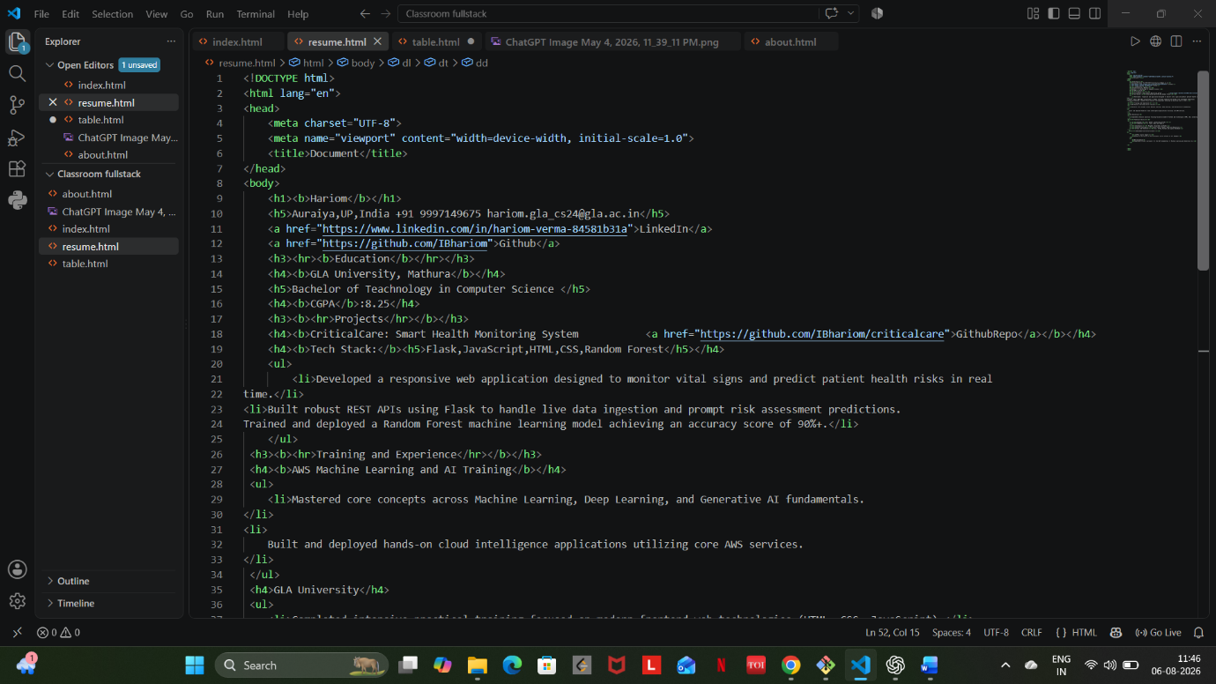

Q 8
Static Website: A website with fixed content that is the same for every user. It is built using HTML, CSS, and JavaScript and does not require server-side processing.
Example: Portfolio website, company information website.
Dynamic Website: A website whose content changes based on user input, database, or server-side processing. It uses backend technologies such as PHP, Python, Java, or Node.js along with databases like MySQL or MongoDB.
Example: Amazon, Facebook, Instagram, Gmail.

Q 9

Different browsers use different rendering engines, which affects speed, compatibility, privacy, and performance.
- Blink is the most widely used engine and offers excellent speed and compatibility.
- Gecko emphasizes privacy, openness, and web standards.
- WebKit is optimized for Apple's ecosystem, providing efficient performance and lower power consumption on Apple devices.

Q 10

Client (Browser)
│
▼
HTTP Request
│
▼
Web Server
│ │
▼ ▼
APIs Database
│ │
└───Data──┘
│
▼
Web Server
│
HTTP Response
│
▼
Client (Webpage Displayed)

